**Lab Report**

**Homework 3**

|  |  |
| --- | --- |
| **Name** | **Jing Bi**  ( jb2548 ) |
|  | **Xuanrui Zhang** ( xz572 ) |

**Programming Exercises**

**1. Sentiment analysis of online reviews**

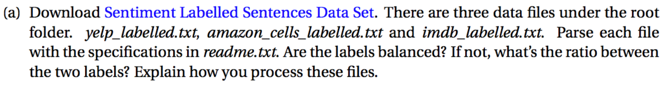

* **Use readlines() to read the file line by line and get rid of \n by .rstrip() and split the comment and the score by .split(’\t’)**

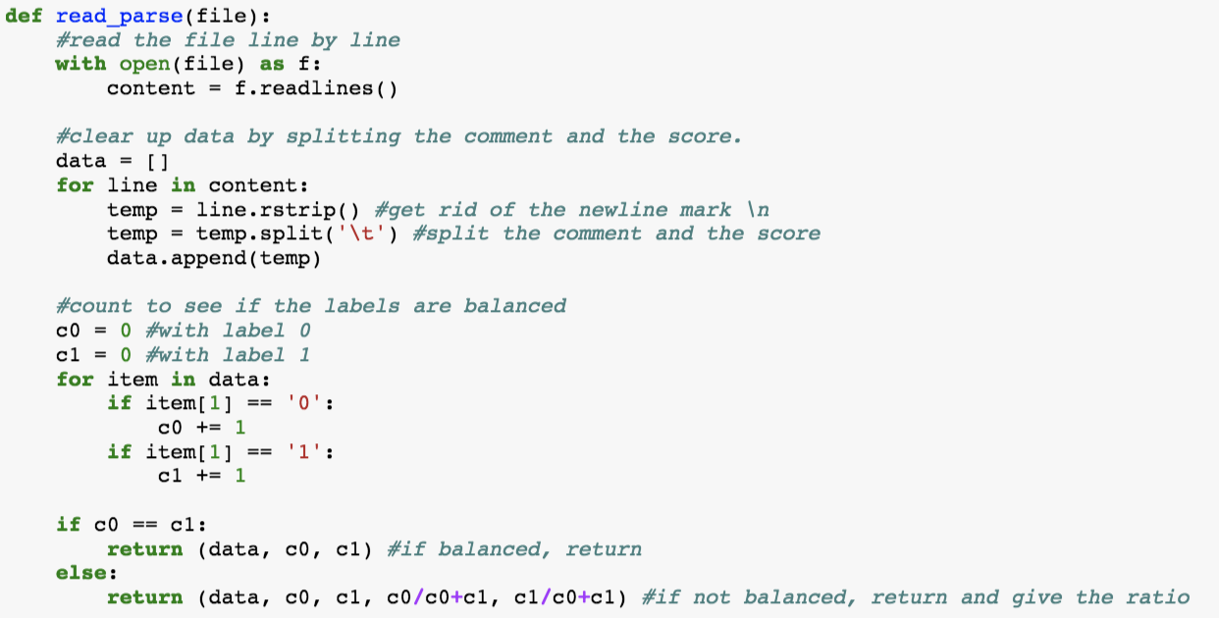

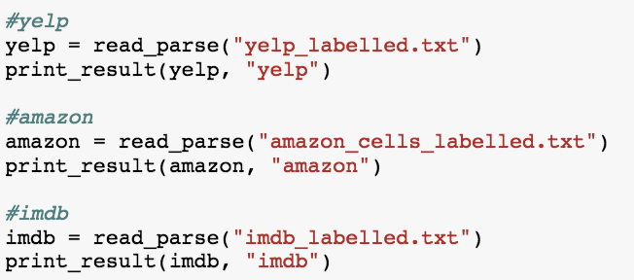

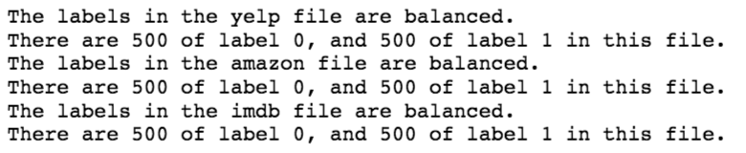

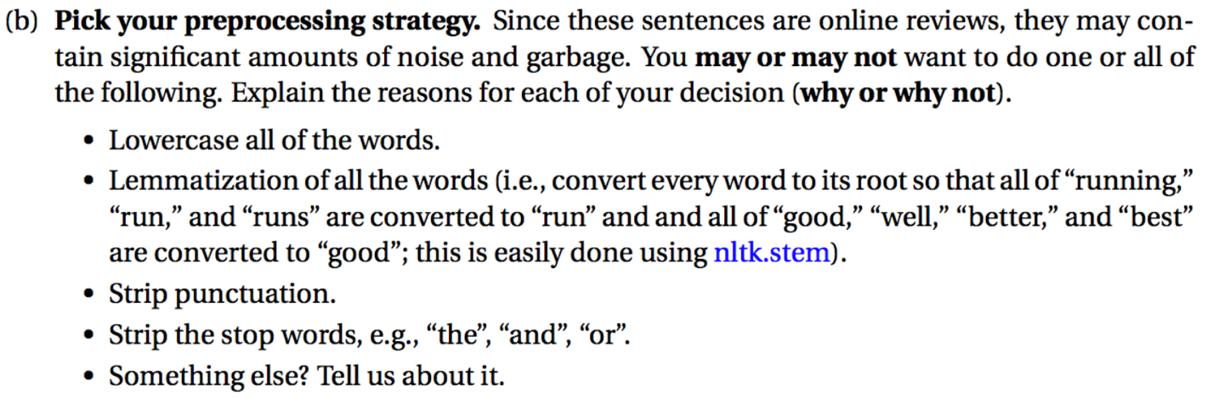

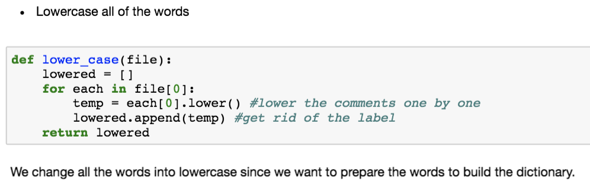

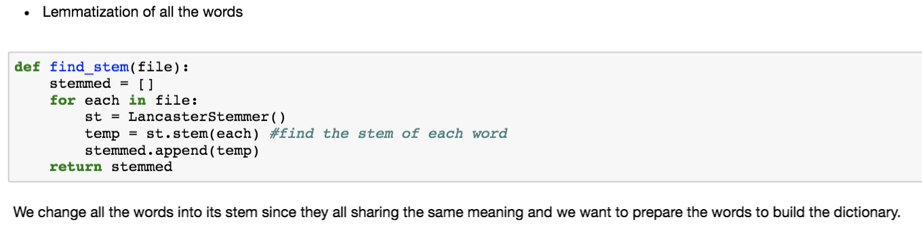

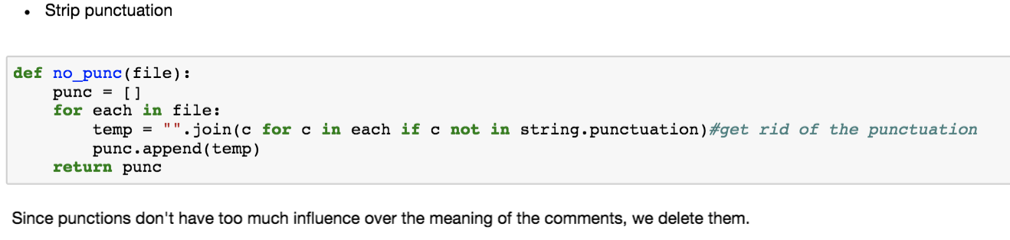

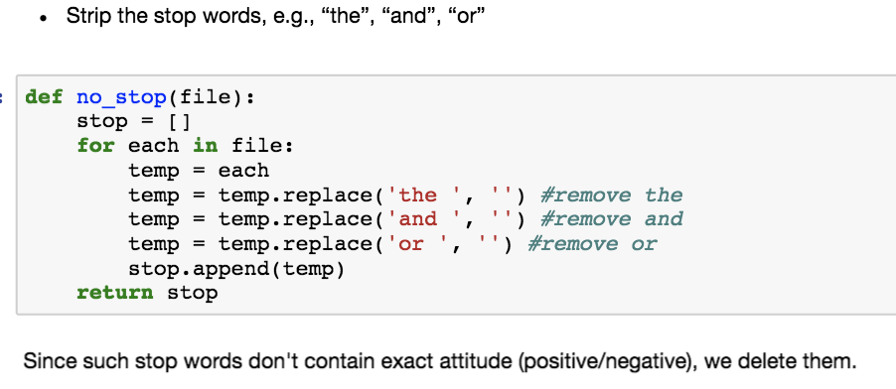

* **Apply the above functions separately onto each review set and print the first 10 entries of cleared data:**

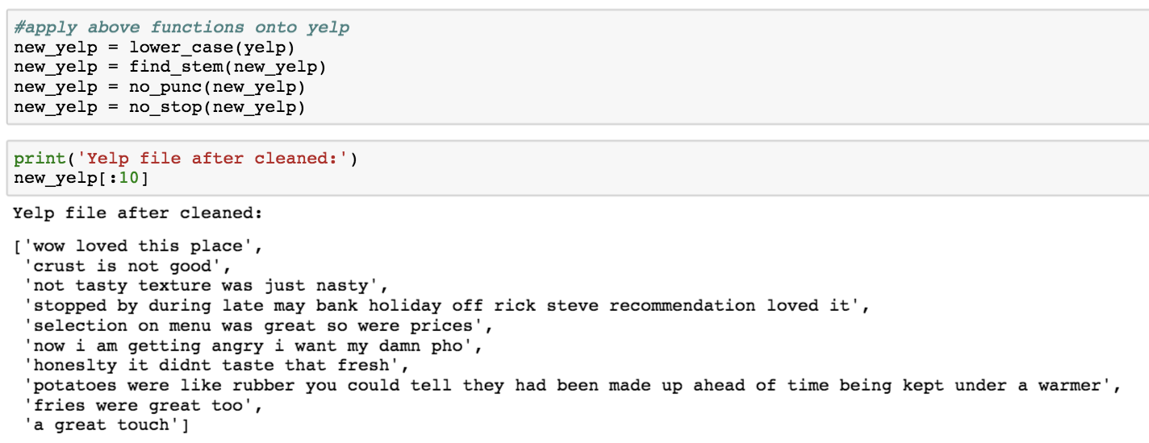

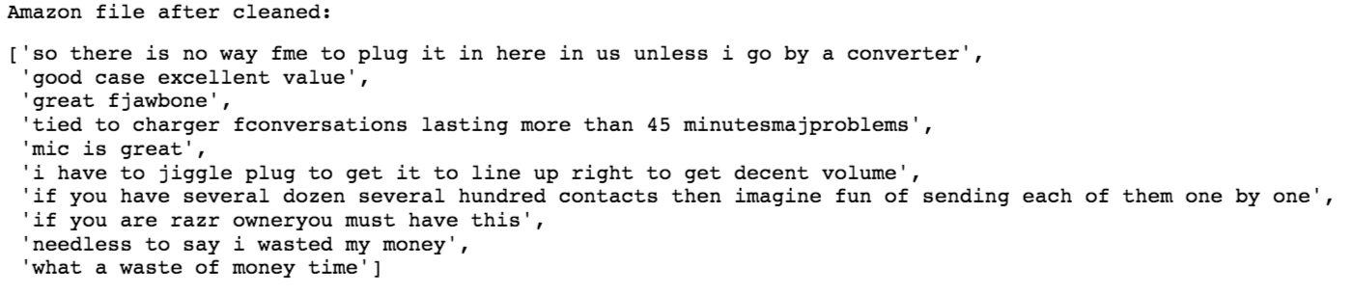

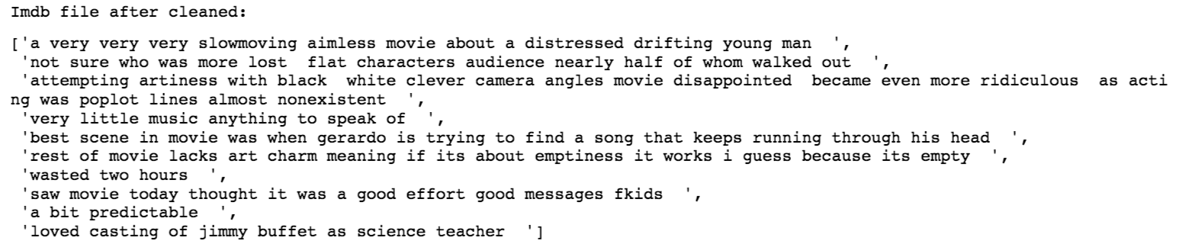



* **Write a function to separate the testing and training data:**

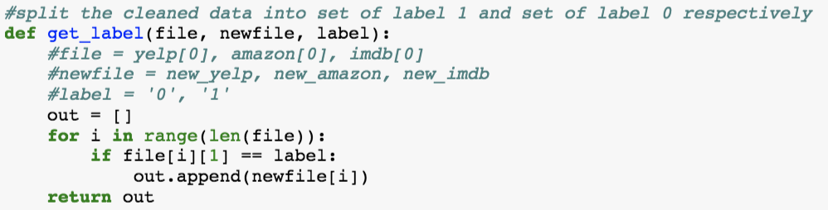

* **Run each data separately through this get_label() function and combine them:**

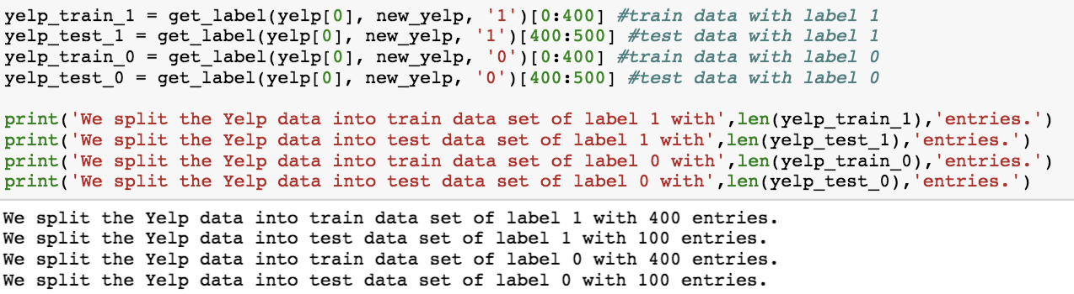

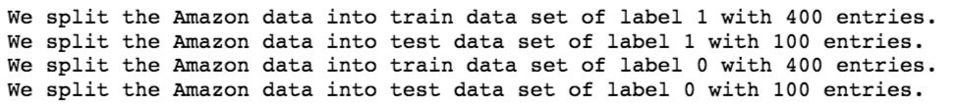

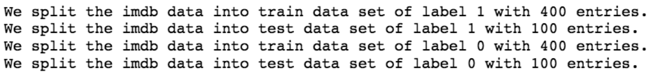

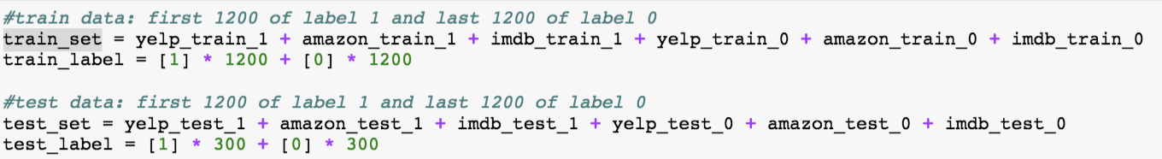

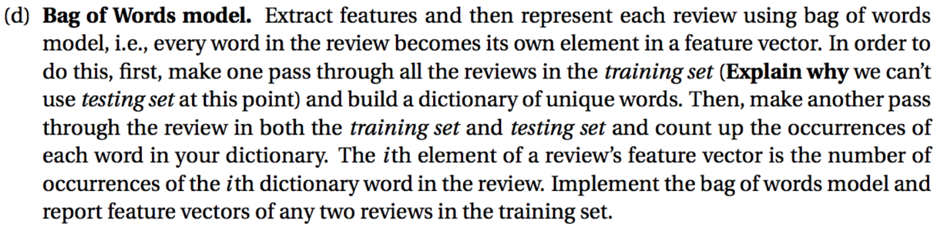

* Create the **bag of words** model for the *training* data
* At this point, we can’t use *testing set* because we want to avoid the mixture of *testing* and *training* sets so that to prevent overfitting.

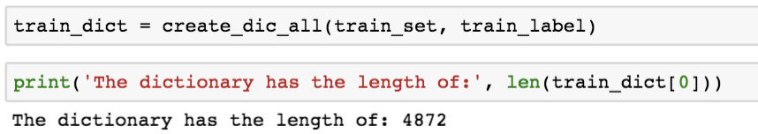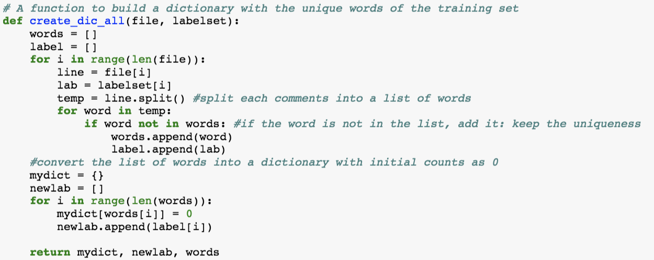

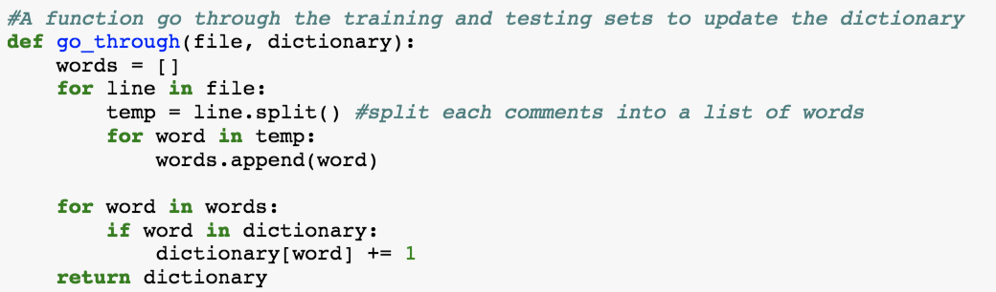

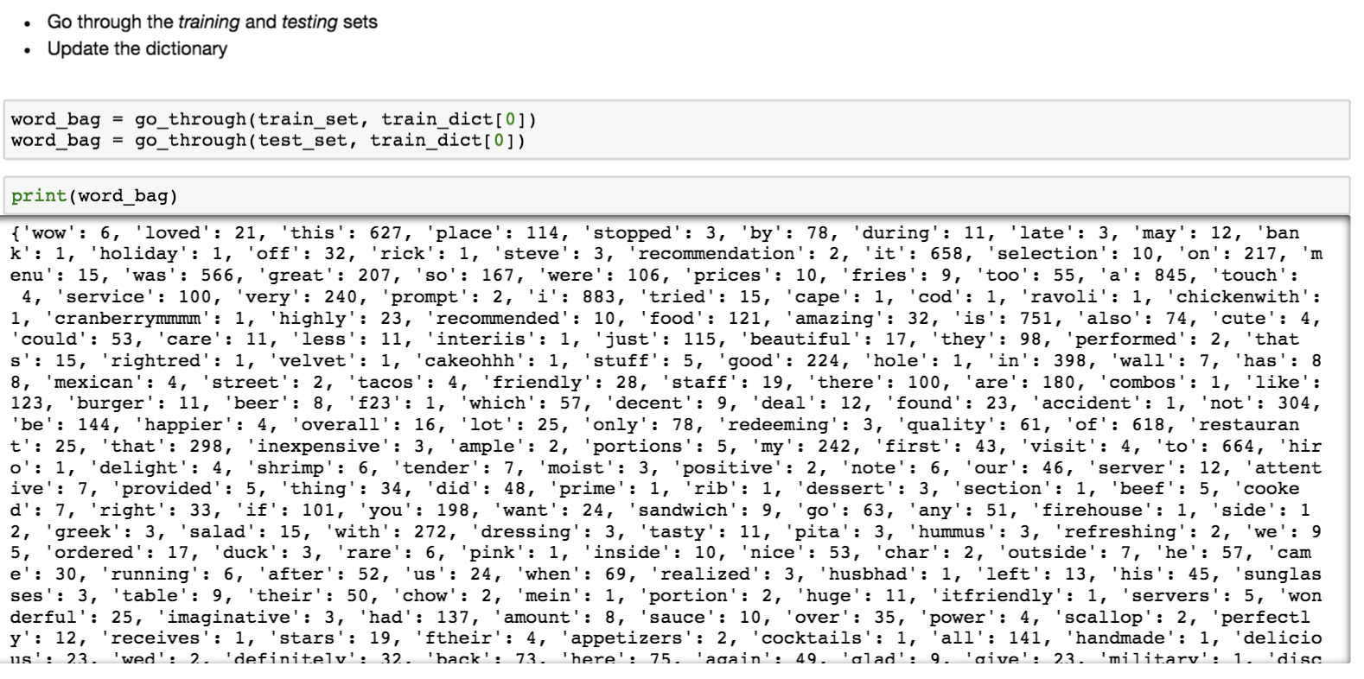

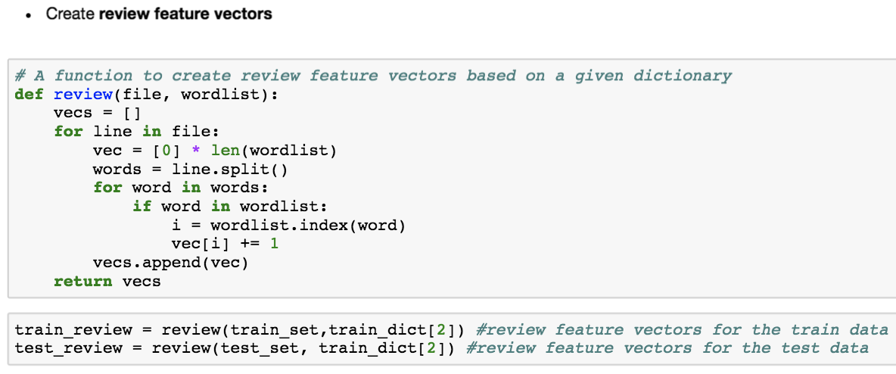

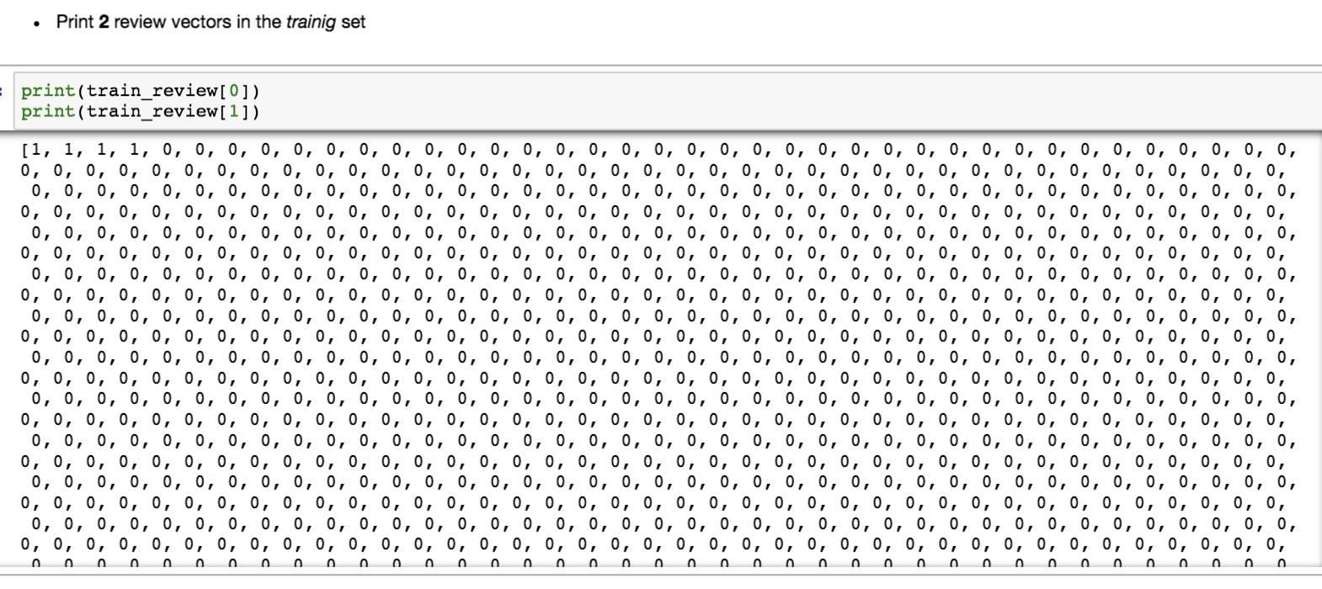

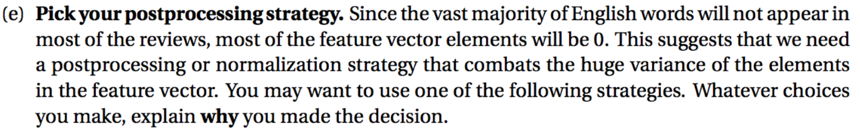

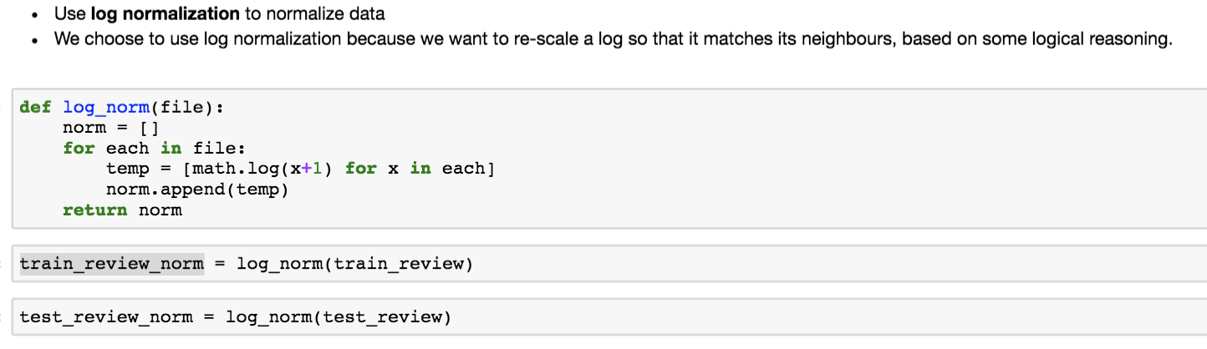

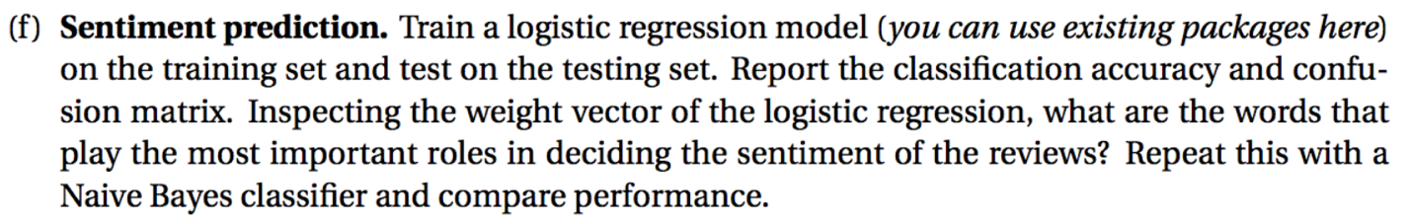

**(1) Logistic Regression Model**

* **Train the data with Logistic Regression model**

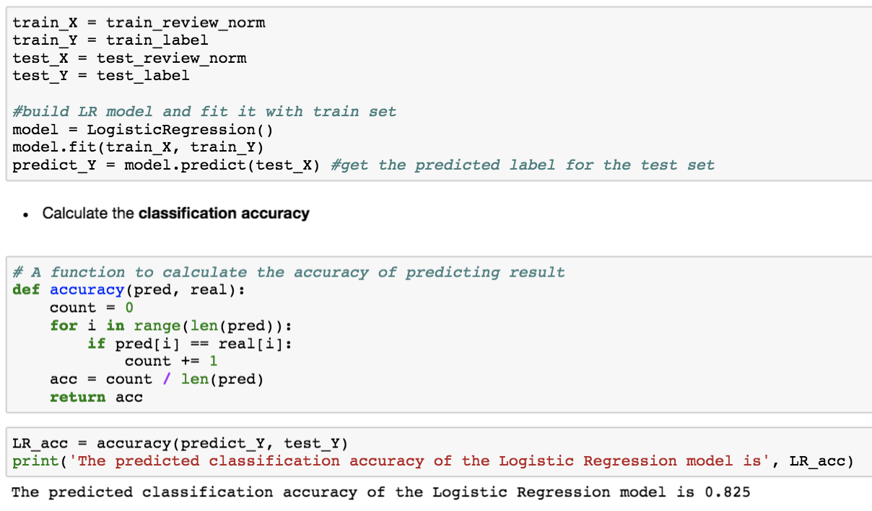

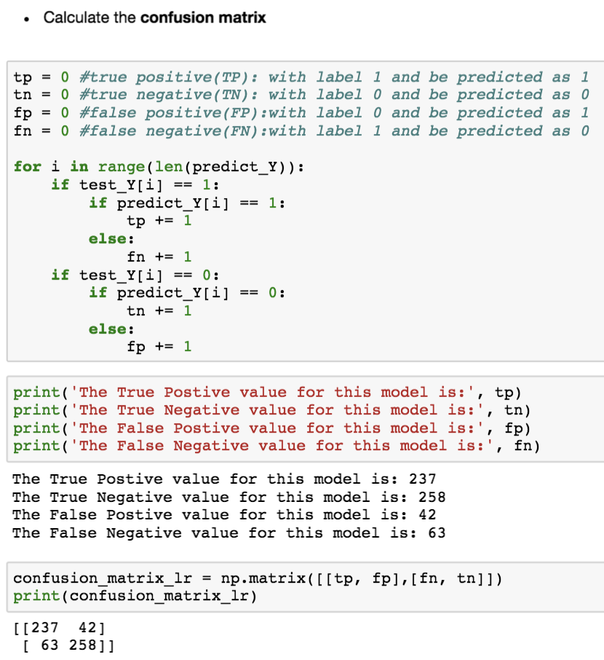

* **Get the words with top 10 frequencies from different groups, and then compare two groups if the word appear only in the top frequency list of one group, then take it as the deciding word of this group:**

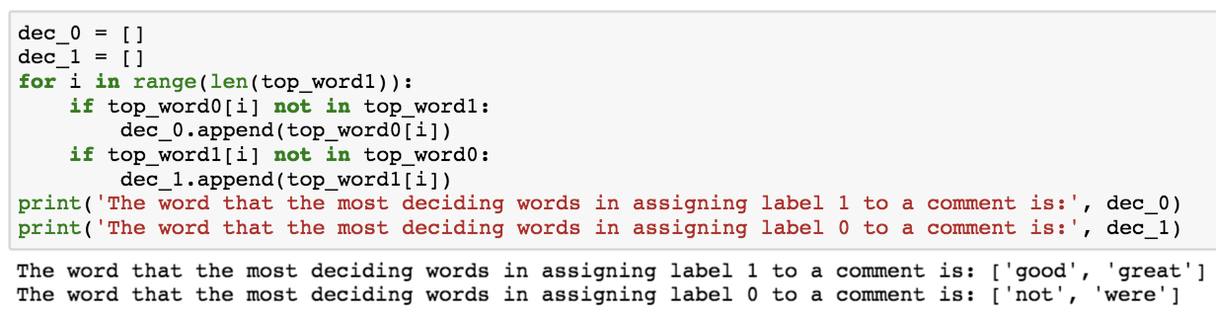

**(2) Repeat the process with Naive Bayes Classifier: Bernoulli Model**

* **Train the data with NB model**

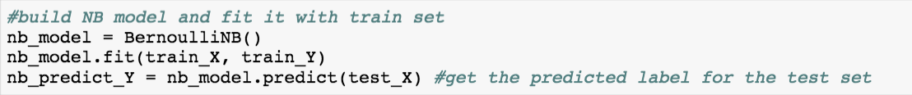

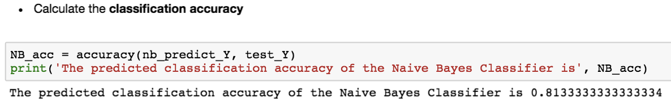



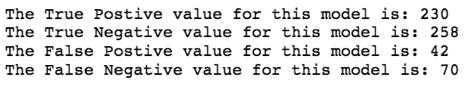 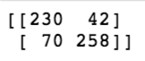

* **Get the deciding words for each group:**



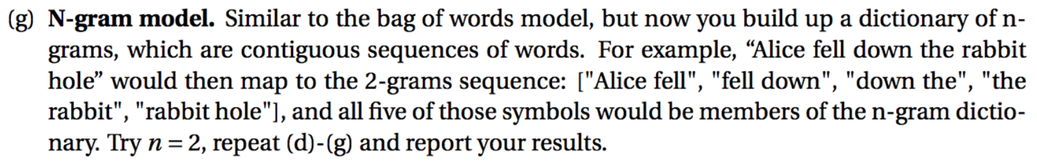

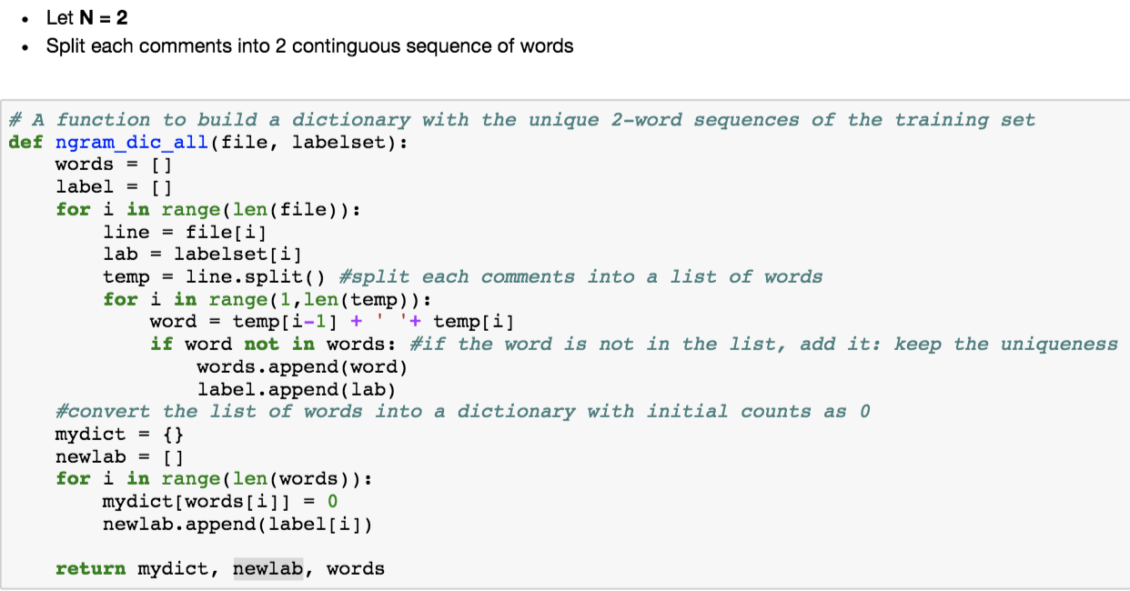

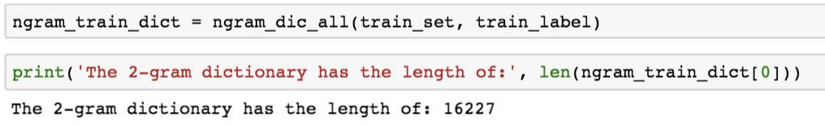

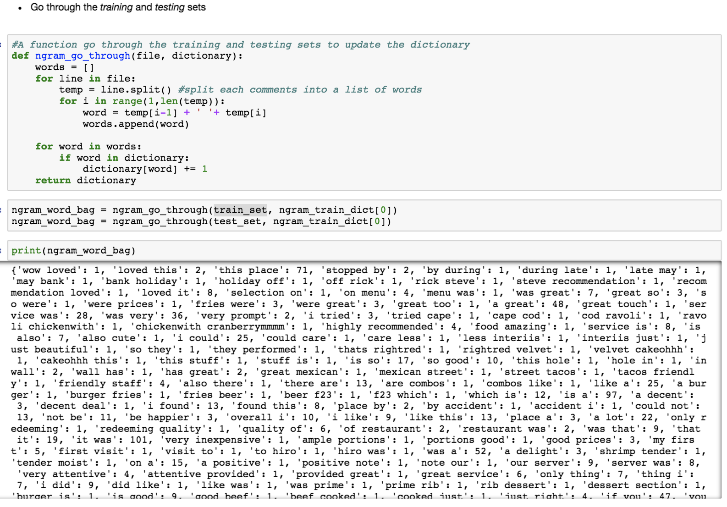

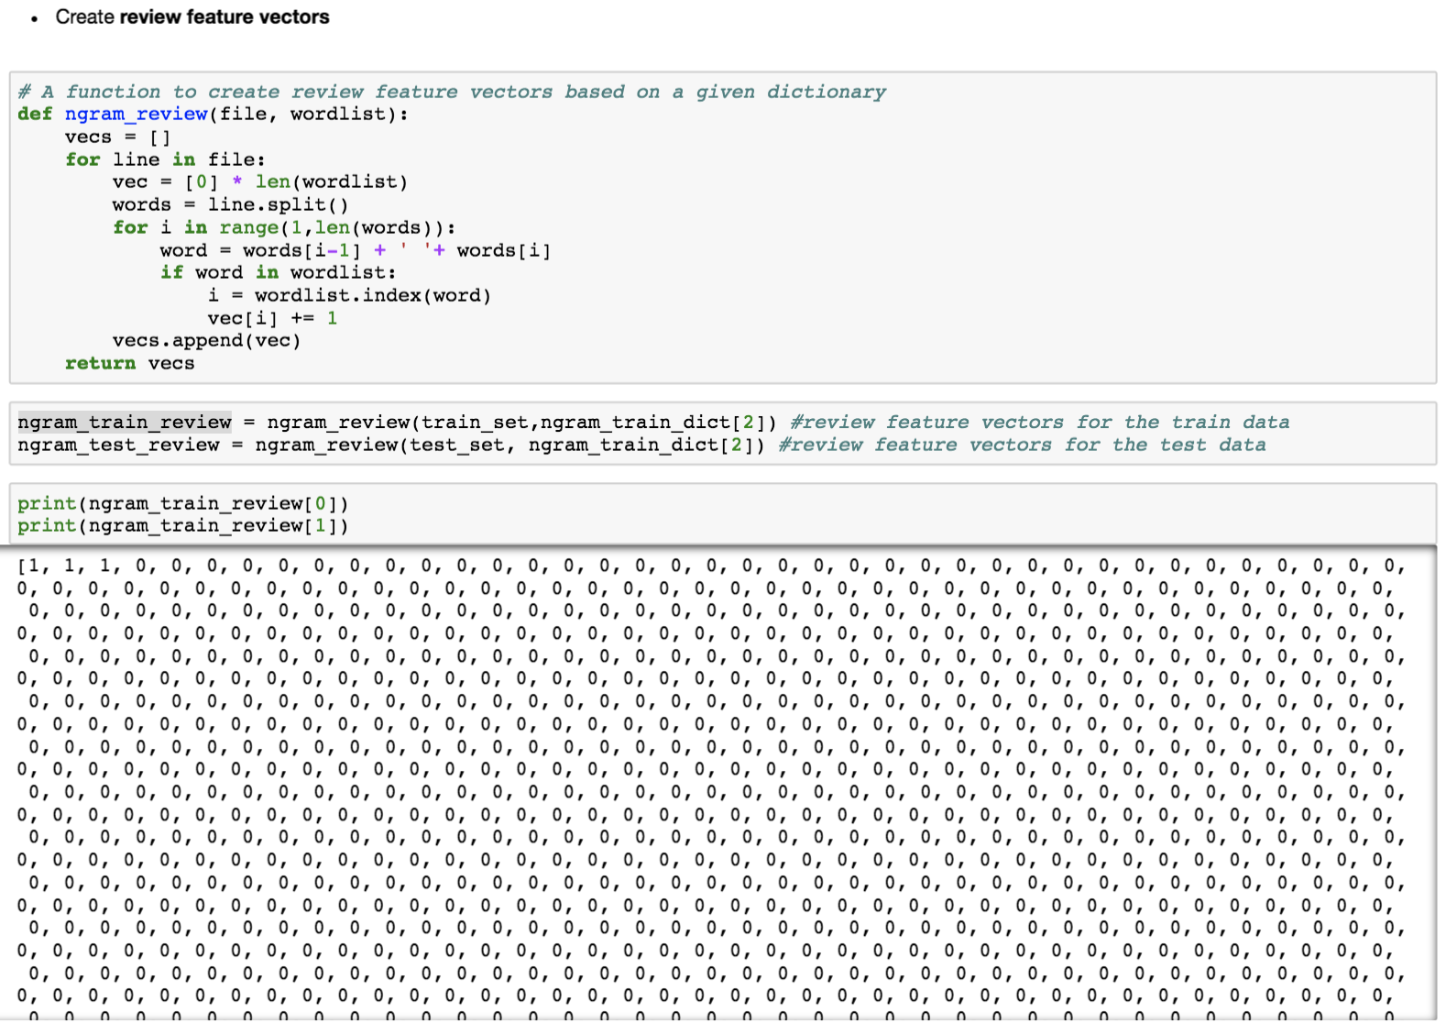

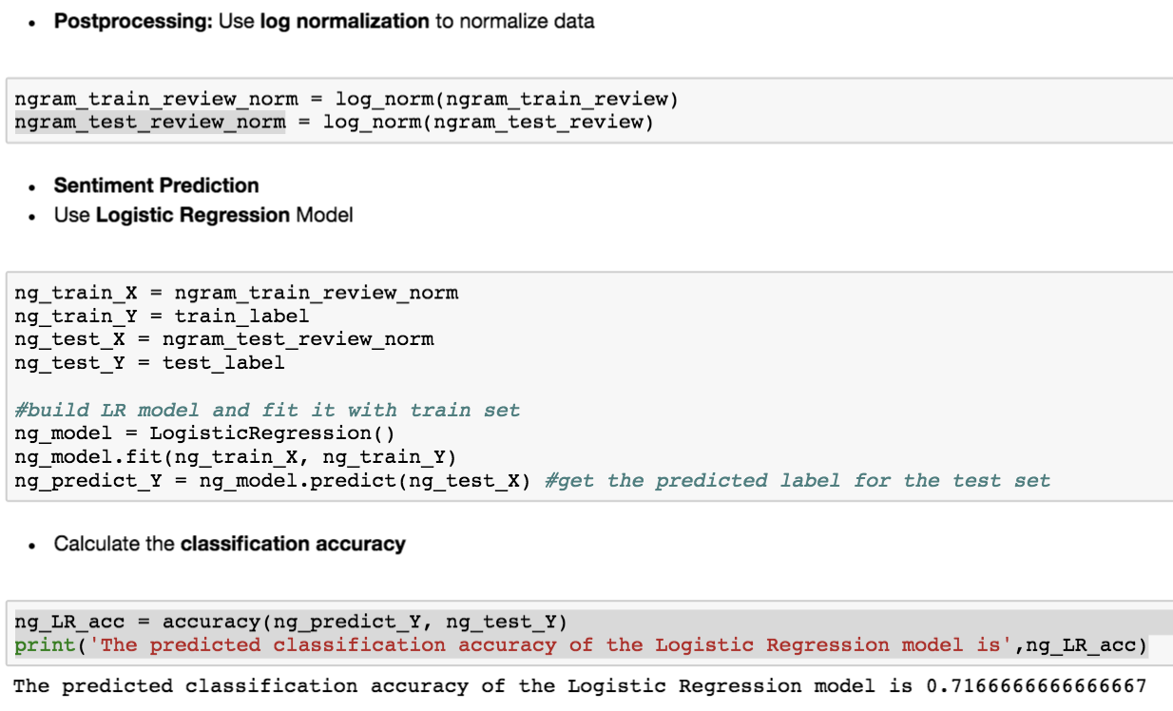

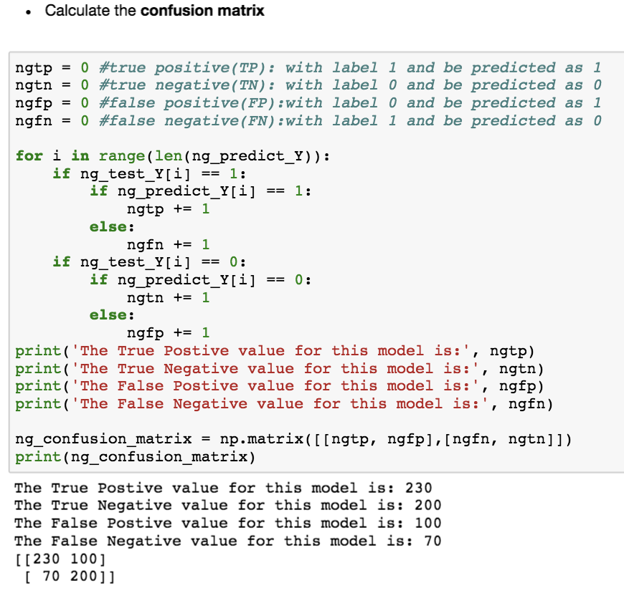

* **The most decising words**

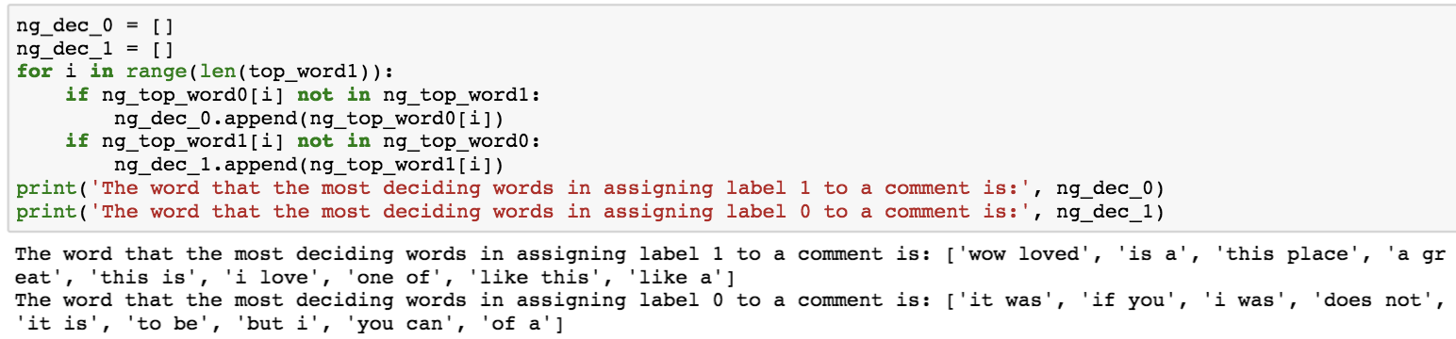

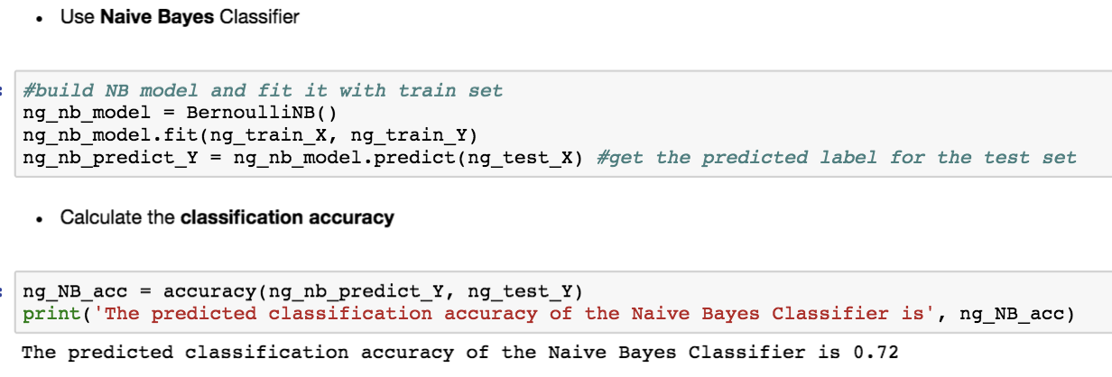



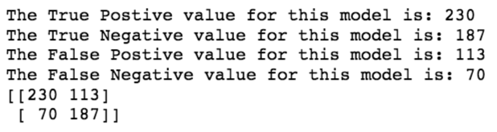

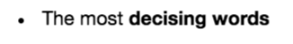

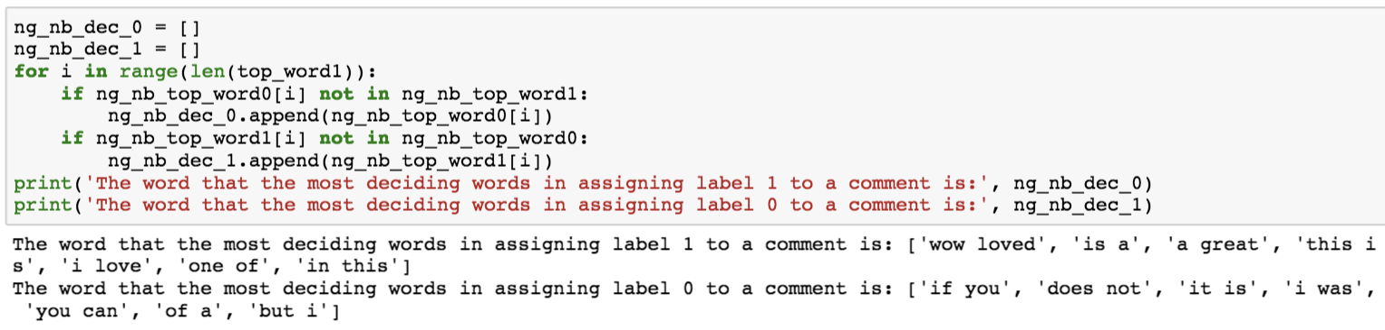

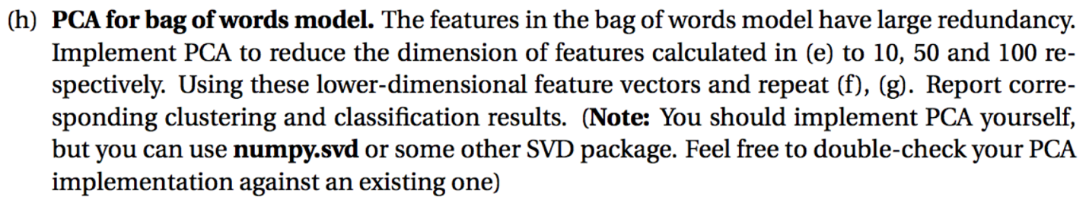

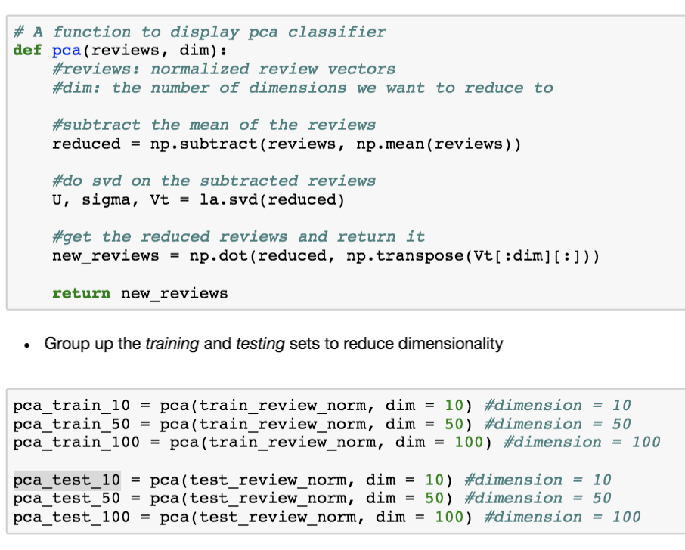

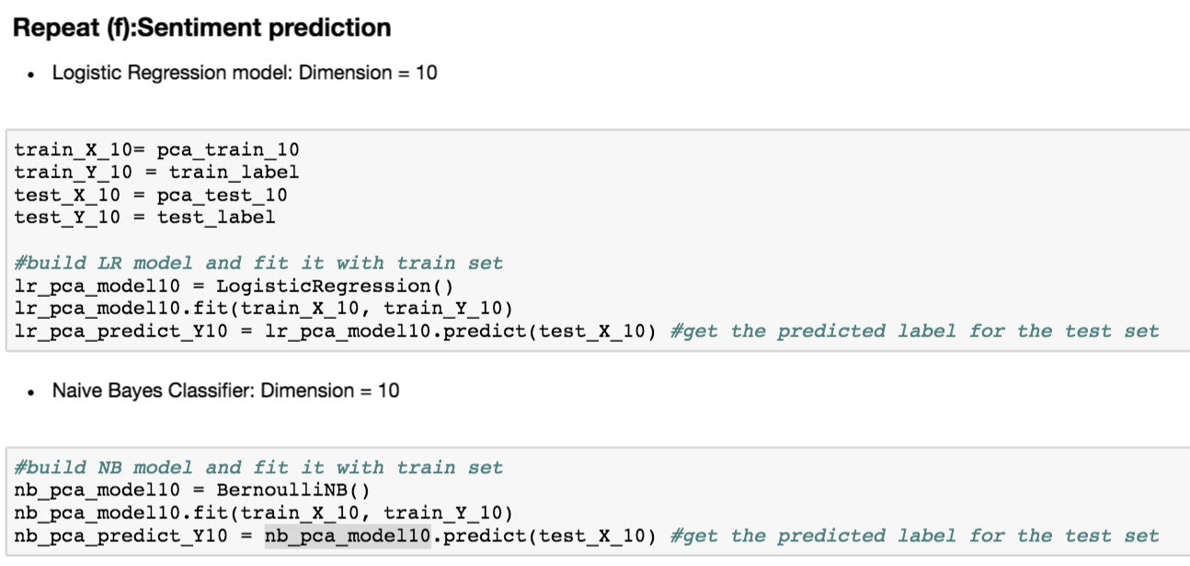

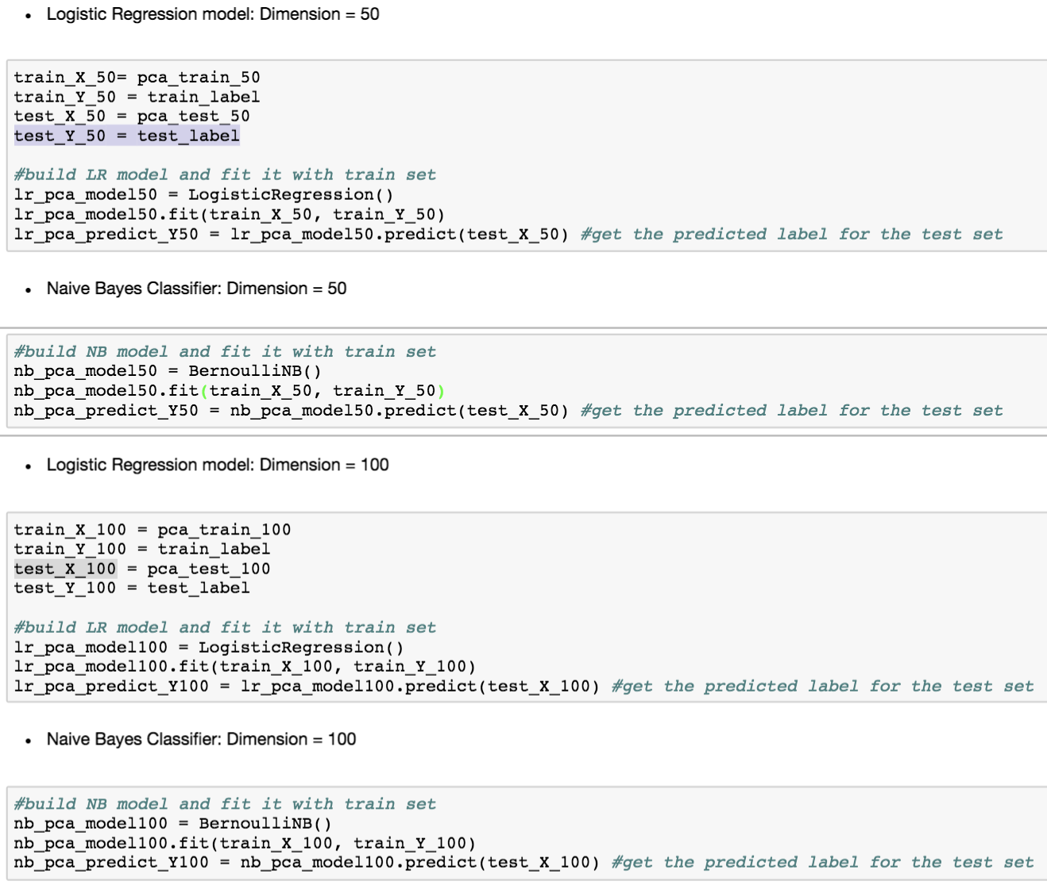

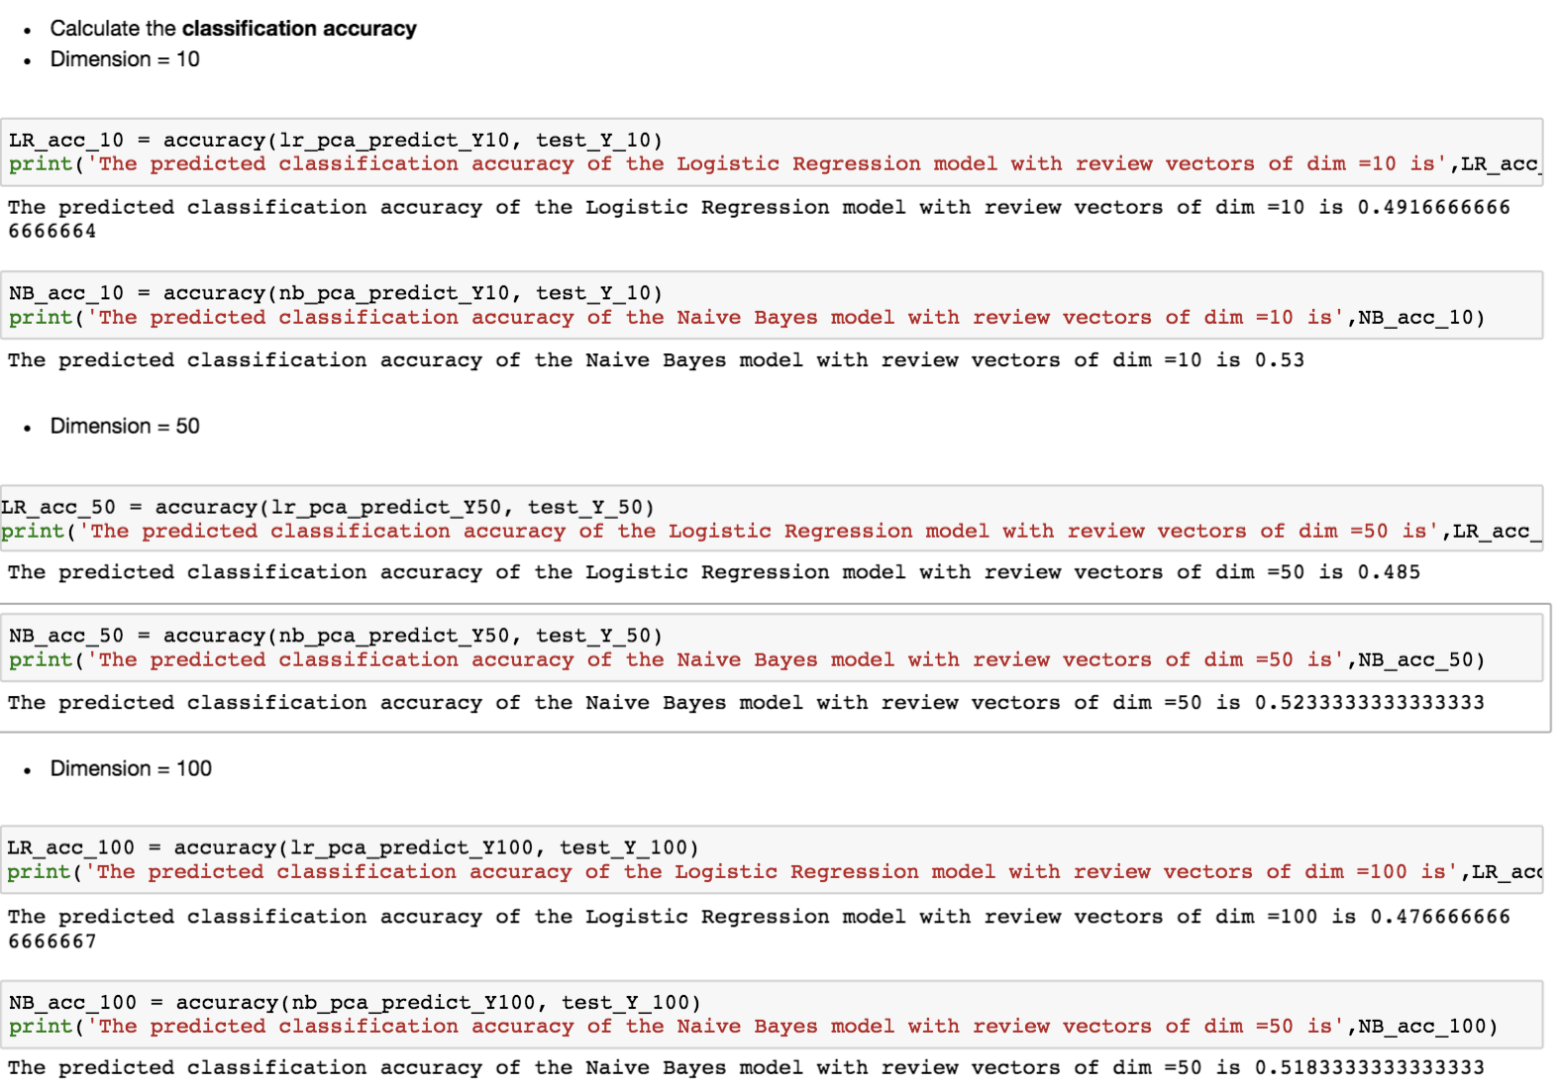

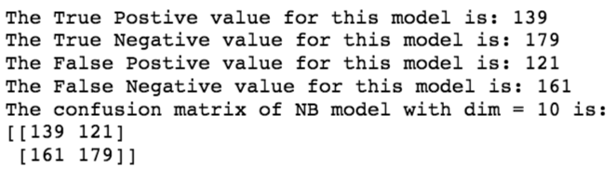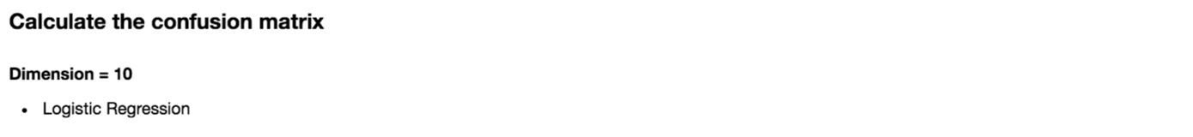

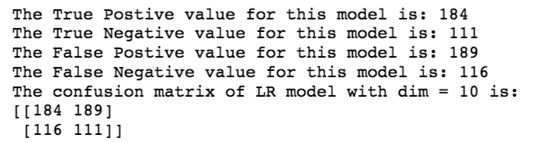

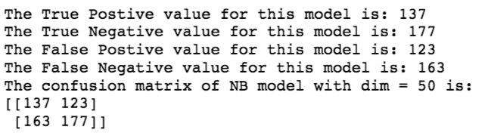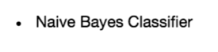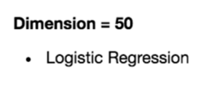

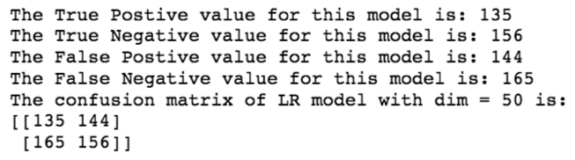

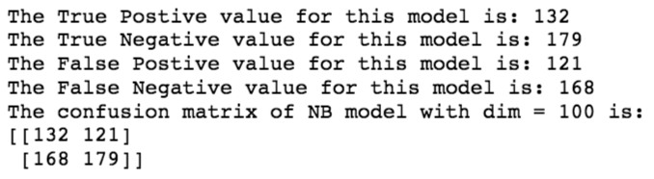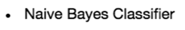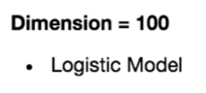

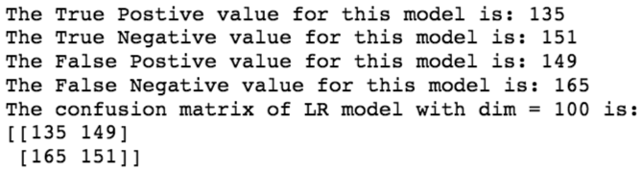

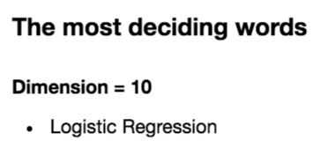







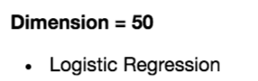



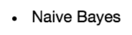



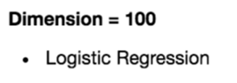



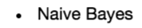



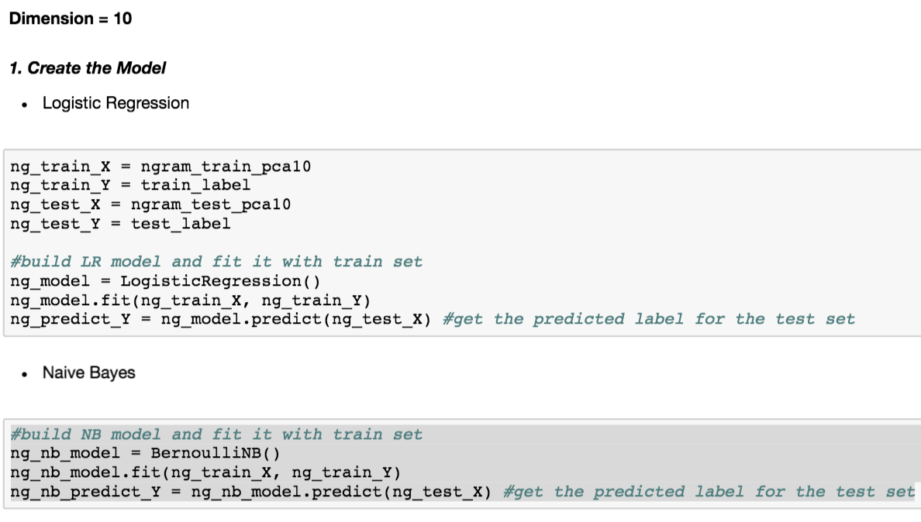

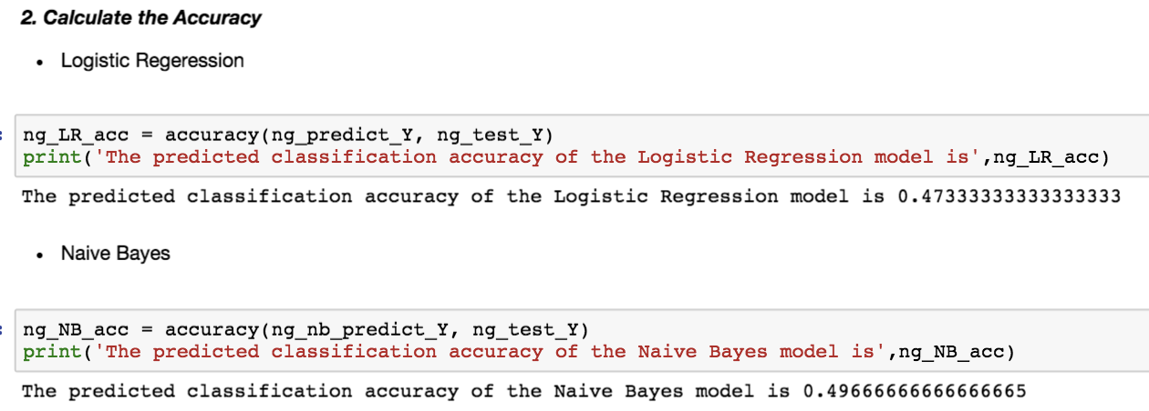

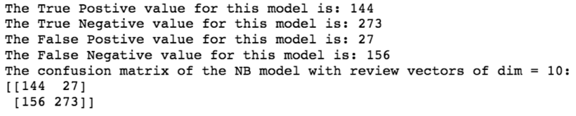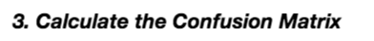

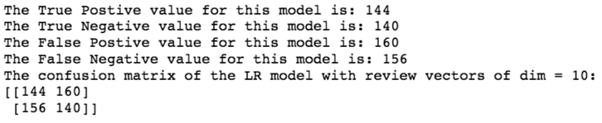

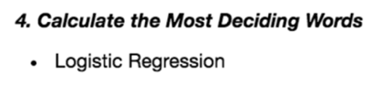







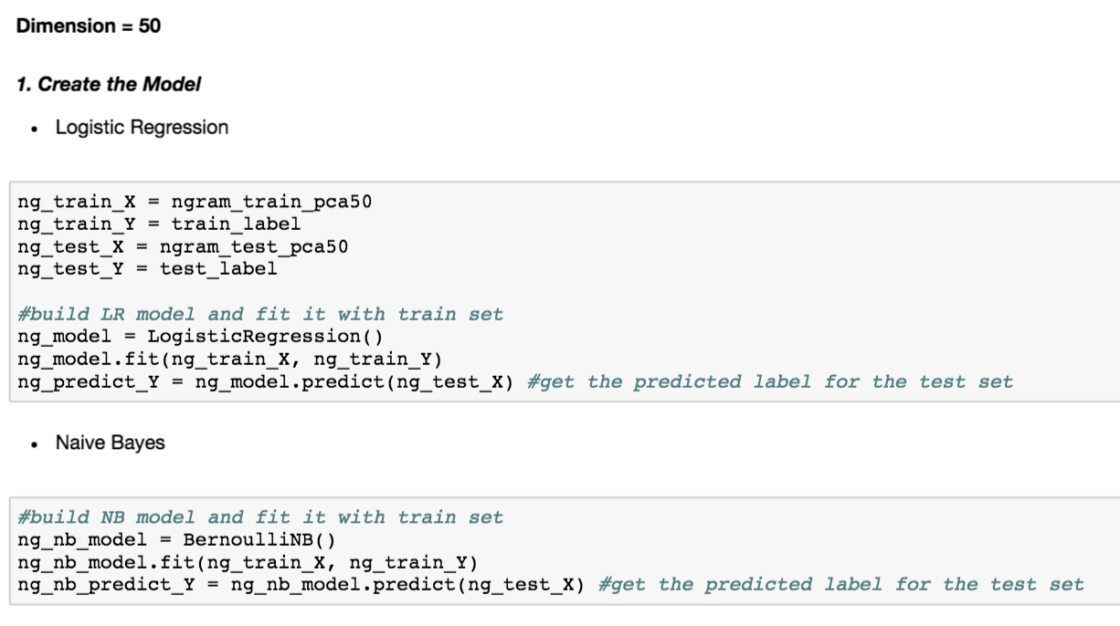

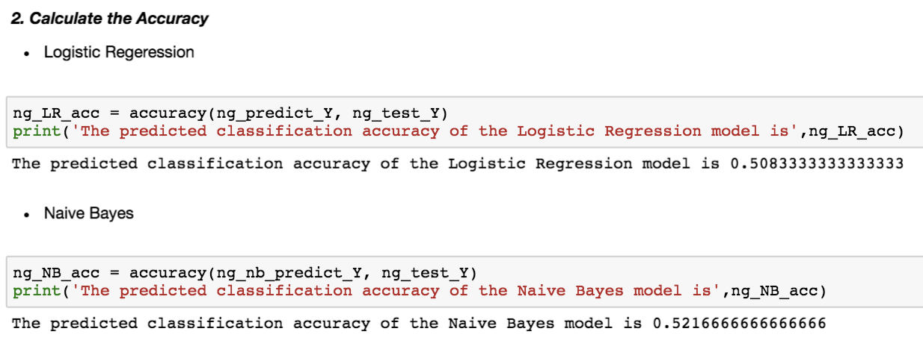

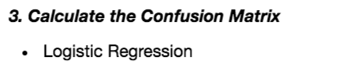

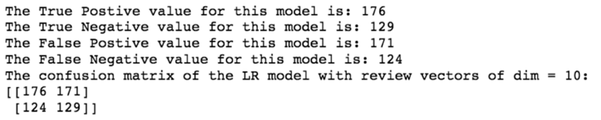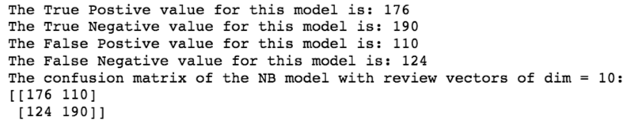

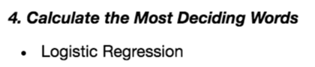







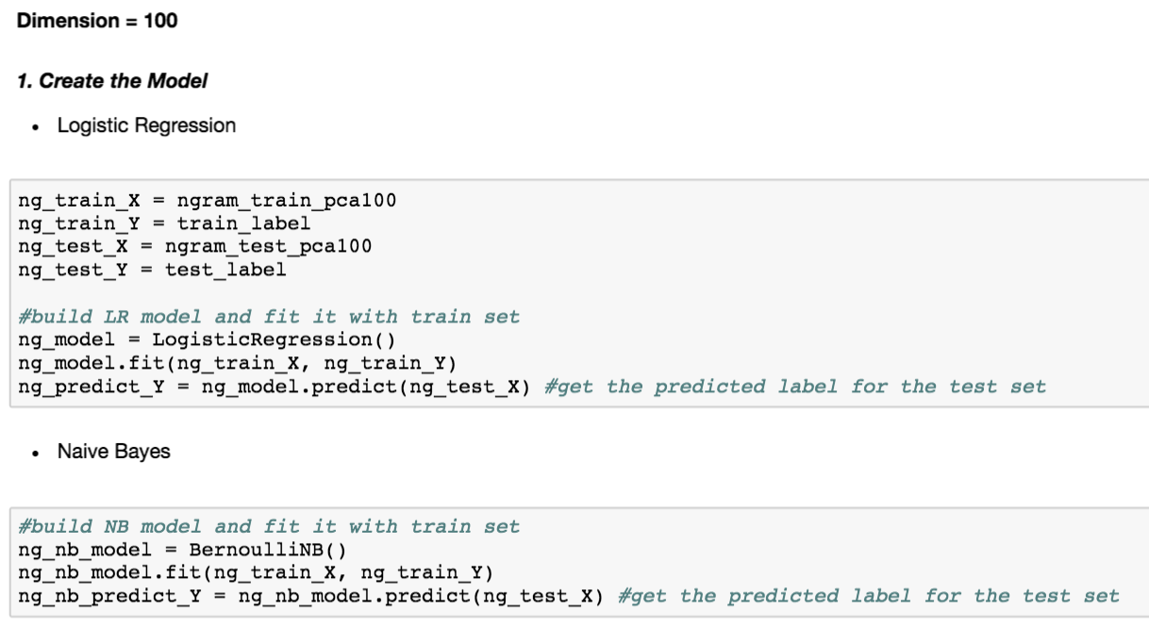

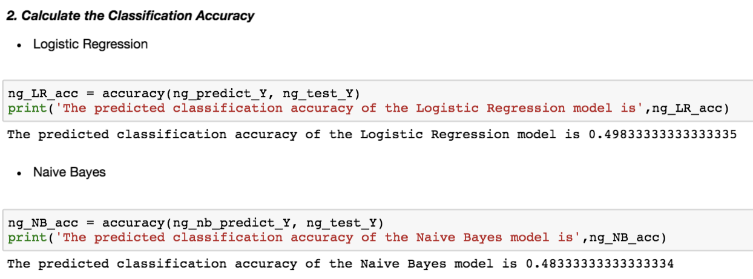

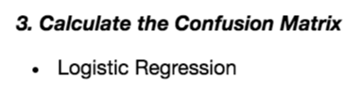

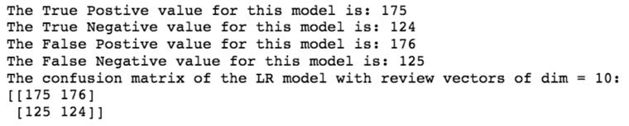

* **Naïve Bayes**

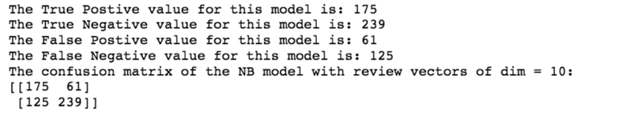

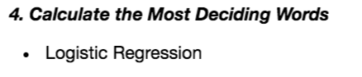







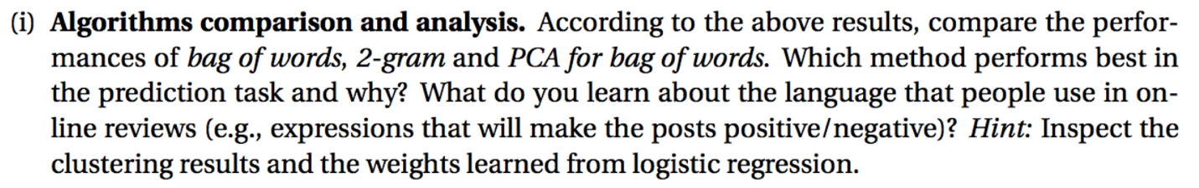

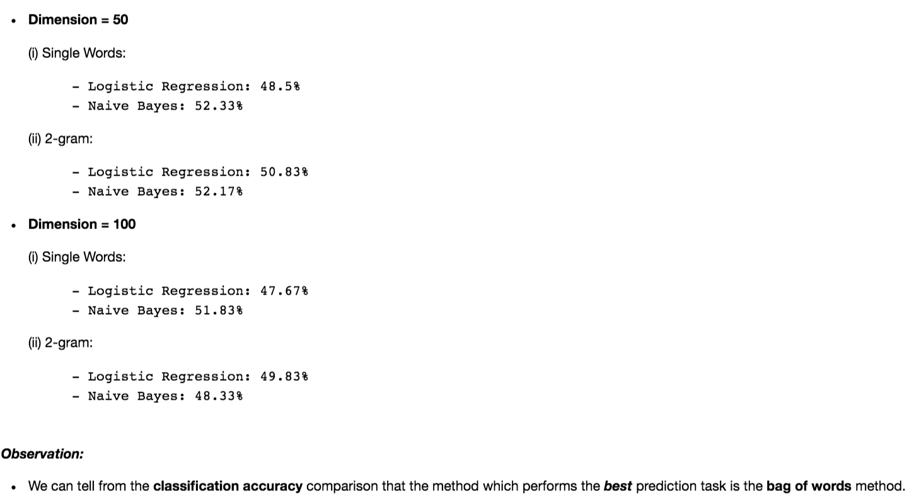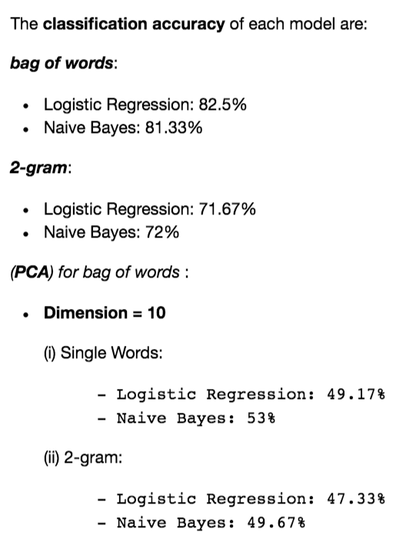

**2. Clustering for text analysis**

**3. EM algorithm and implementation**



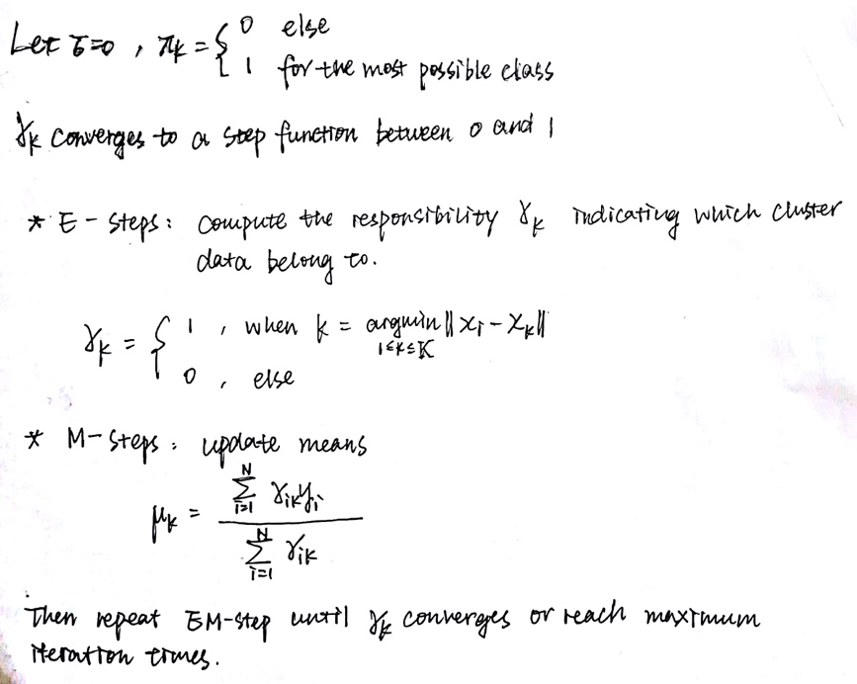



* **Import the data from the .txt file:**

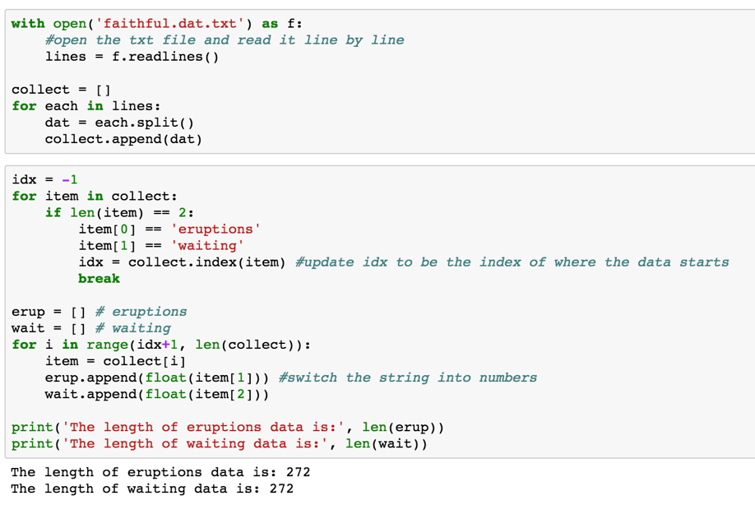

* **The data has 272 entries and 2 features ‘eruptions’ and ‘waiting’ and its plot is as following:**

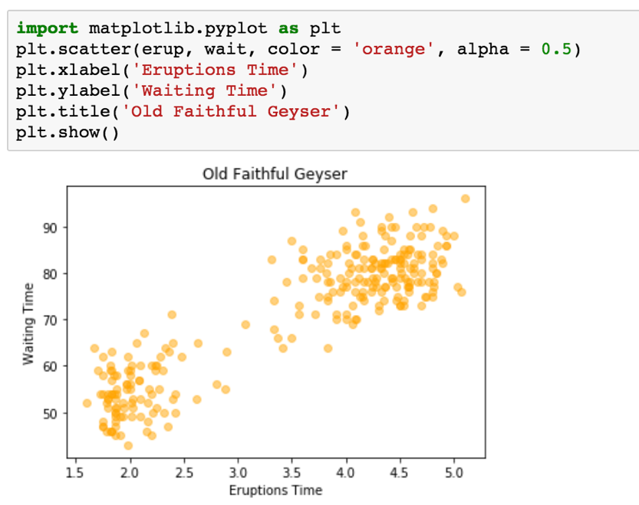

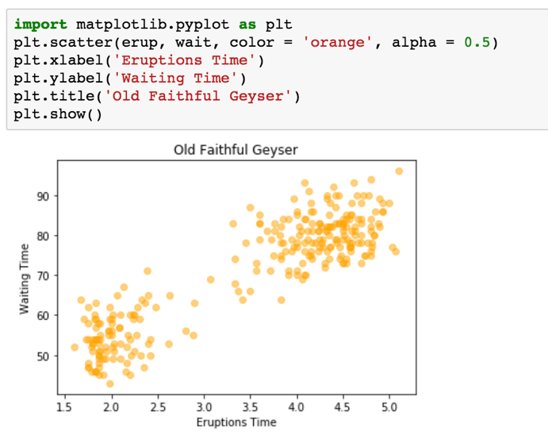

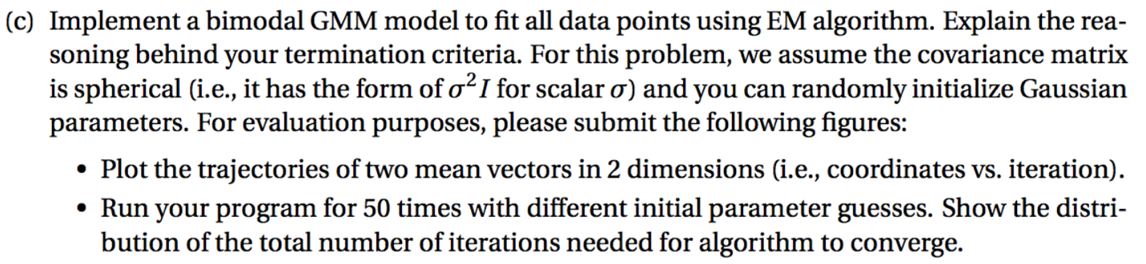

**(1) Write a function to display initial guess of ∑, μ, π: (2) Write functions to display EM-step:**

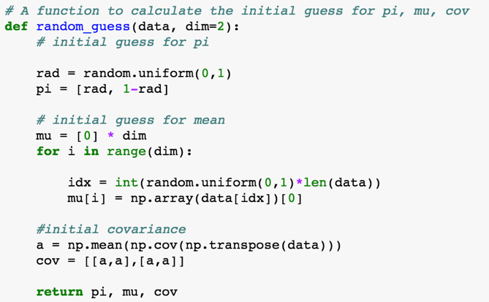

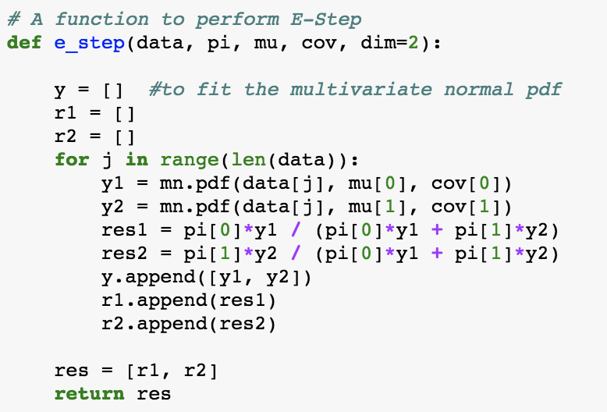

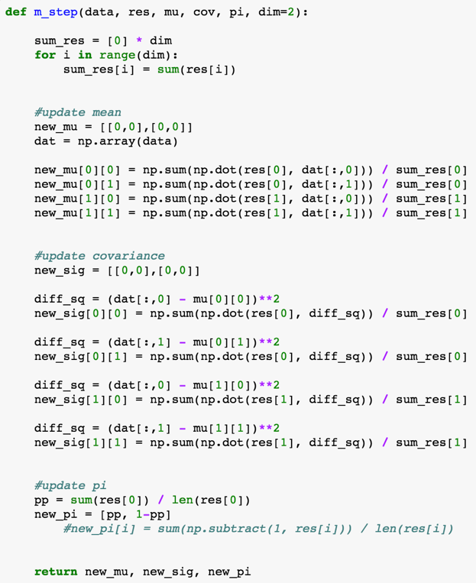

(3) **Write a function to perform GMM:**

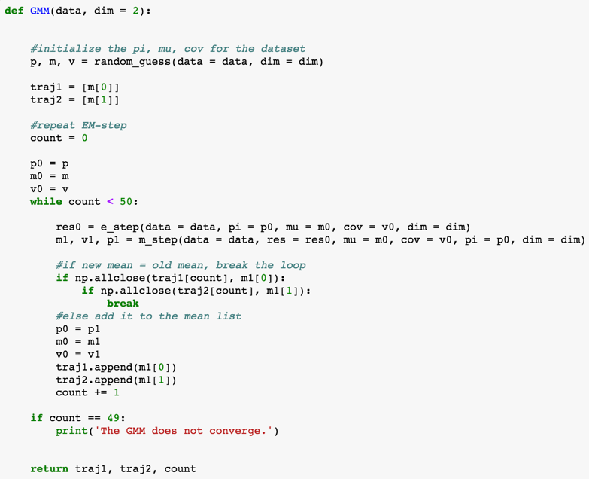

**(4) Plot the trajectories**

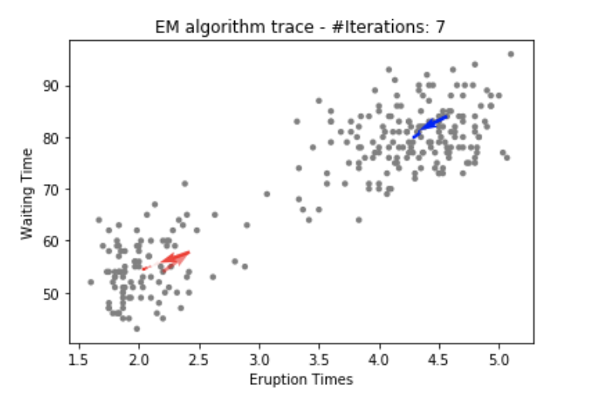

**(5) Repeat 50 times and plot the distribution of #iterations**

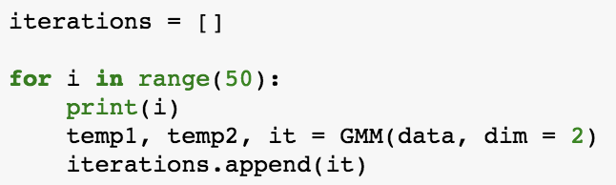

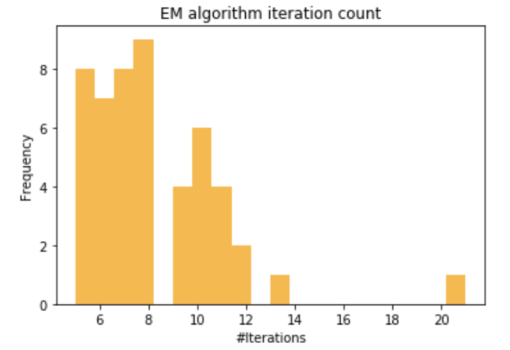

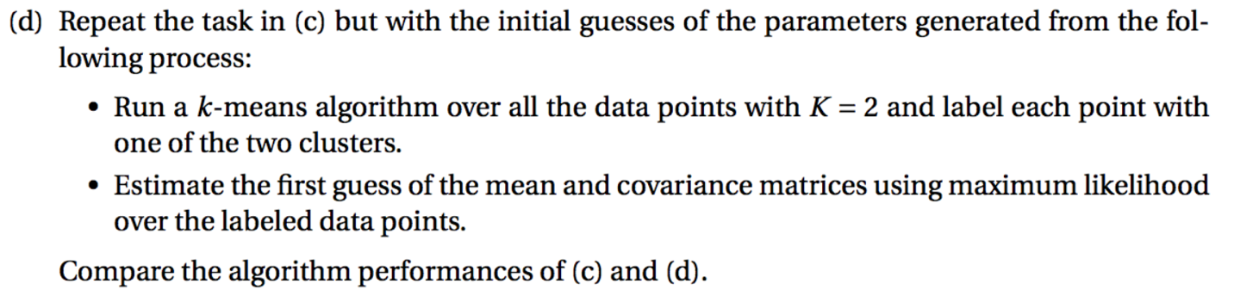

**(1) Write a function to display initial guess of ∑, μ, π by K-Means:**

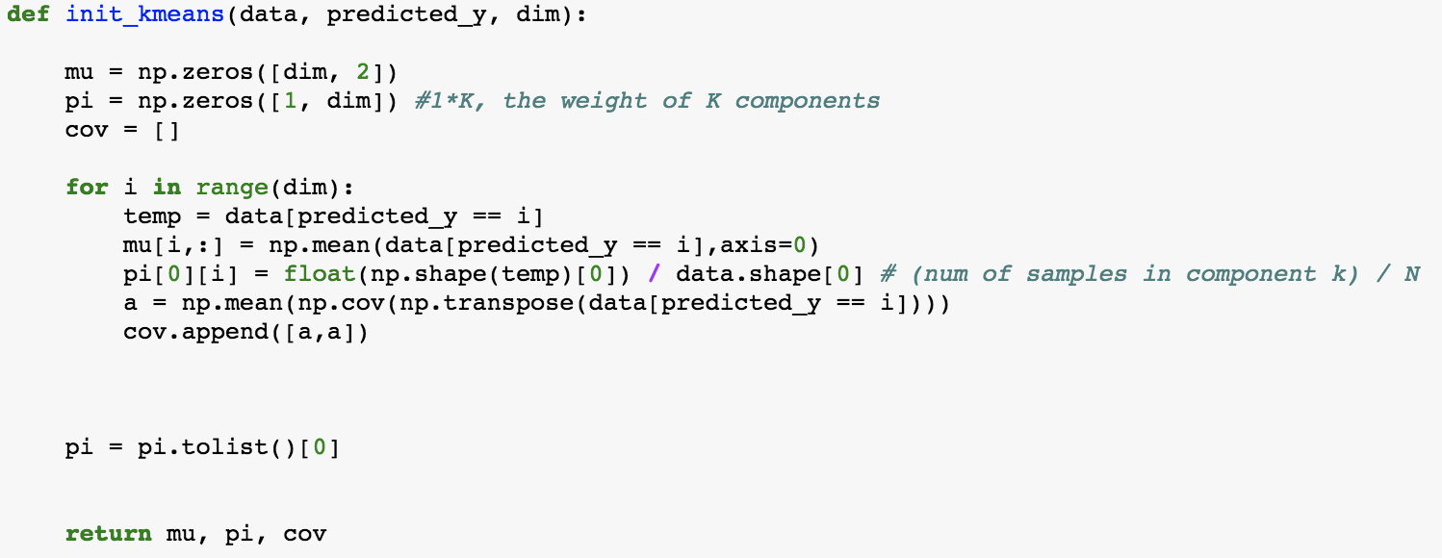

**(2) Apply K-Means with GMM**

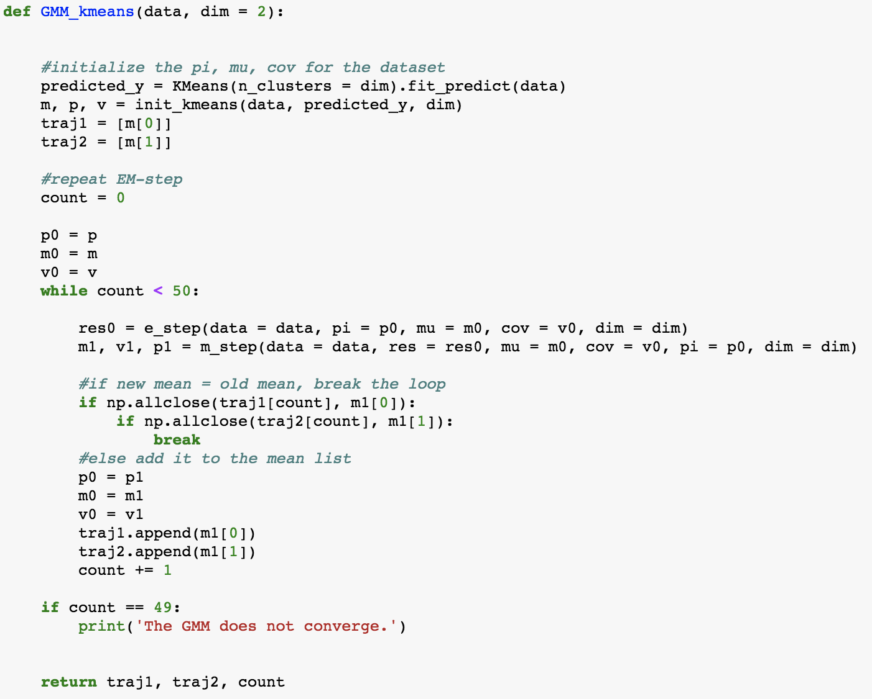

**(3) Plot the trajectories**

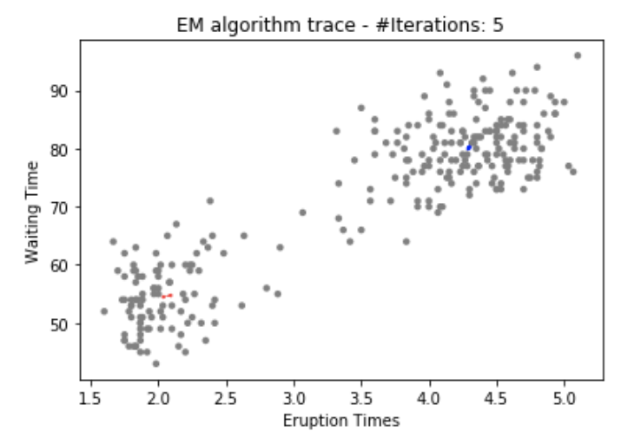

**(5) Repeat 50 times and plot the distribution of #iterations**

